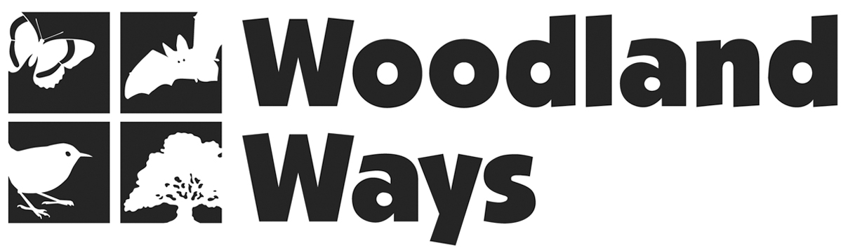

Its Subscription Renewal Time!

Membership is a minimum of just £5 per household

I/ We would like to donation £5... £10... £...

Title................Forename........................Surname........................

Address..........................................................................................

Postcode........................................................................................

Names & ages of children if applicable......................................

........................................................................................................

Telephone......................................................................................

Email...............................................................................................

Signed............................................................................................

Date.................................................................................................
If you are a UK taxpayer
Gift Aid allows us to reclaim 28% of the money you donate
I would like Woodland Ways to reclaim tax on any payment I make as Gift Aid.
I have paid an amount of UK Income Tax or Capital Gains Tax equal to any tax deducted.
Please delete if not applicable.

Please make cheques payable to Woodland Ways and send to:
Woodland Ways, 16 Downing Close, Bury St Edmunds IP32 7HU

Its Subscription Renewal Time!

Membership is a minimum of just £5 per household

I/ We would like to donation £5... £10... £...

Title................Forename........................Surname........................

Address..........................................................................................

Postcode........................................................................................

Names & ages of children if applicable......................................

........................................................................................................

Telephone......................................................................................

Email...............................................................................................

Signed............................................................................................

Date.................................................................................................
If you are a UK taxpayer
Gift Aid allows us to reclaim 28% of the money you donate
I would like Woodland Ways to reclaim tax on any payment I make as Gift Aid.
I have paid an amount of UK Income Tax or Capital Gains Tax equal to any tax deducted.
Please delete if not applicable.

Please make cheques payable to Woodland Ways and send to:
Woodland Ways, 16 Downing Close, Bury St Edmunds IP32 7HU

